Emc-variable-3-0.x86_64.rpm is a rpm package which is bundled with a set of tools needed to troubleshoot vProxy issues. It is aimed at easing the process of deploying and deploying the tools. In the current version we have added 4 scripts/tools.
- ProxyHC
https://support.emc.com/kb/504797

- ddpconncheck

https://emcservice--c.na55.content.force.com/servlet/fileField?id=0BEj0000000Gtj5

https://emcservice--c.na55.visual.force.com/apex/KB_How_To?id=kA5j00000008TeD

- vProxyDebugEnabler.sh

https://inside.dell.com/docs/DOC-326562

- emc-variable.sh script Depreciated.

Have removed the option to download ProxyHC as its now part of the bundle.

https://inside.dell.com/docs/DOC-274307?sr=stream

Install instructions:

- As root move the rpm “emc-variable-3-0.x86_64.rpm” to “/tmp” on vProxy and change permissions to 755

- Install the rpm using root account.

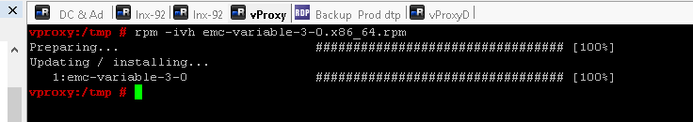

- Verify the following tools exist at the corresponding location and have the appropriate permissions (755)

/etc/profile.d/emc-variable.sh
/opt/emc/vproxy/support-tools/ProxyHC
/opt/emc/vproxy/support-tools/ddpconnchk_linux_64
/opt/emc/vproxy/support-tools/vProxyDebugEnabler.sh
- To uninstall the tools run the following command
rpm -e emc-variable-3-0.x86_64
- Verify the following tools exist at the corresponding location.

- If you have deleted a tool and want to restore it please run the following command.

rpm -Uvh emc-variable-3-0.x86_64.rpm –force

